Tracking Bipolar Mood States with Survey Data  
Individual Project Submission

Timothy Crone  
tcrone3@gatech.edu

Contents

1 Video 1

2 GitHub 1

3 Overview 2

3.1 Problem 2

3.2 Solution 2

3.3 Complexity or Effort 3

3.4 Background or Significance 3

3.5 References 4

4 Manual 5

4.1 Patient Interface 5

4.2 Provider Interface 9

4.2.1 Provider Survey Interface 10

4.2.2 Provider Charting Interface 11

5 Final Gantt Chart 13

# Video

<https://youtu.be/N7xBmu1UcHk>

# GitHub

Link: <https://github.gatech.edu/tcrone3/cs6440-individual>

Commit ID: 2cdb98ecf469c3f257b6fbf0286caaa6738addeb

# Overview

## Problem

Depressive states in bipolar patients can lead to symptoms that are substantially different from other depressive disorders (Berk et al., 2007). This results in misdiagnoses or ineffective treatments by psychiatric generalists, ending in poor outcomes for the patient. To help improve diagnosis of bipolar depression, Berk et al. proposed and studied a paper instrument, the bipolar depression rating scale (BDRS), that provides clear guidance to providers as they are diagnosing and treating depressive mood states (2007).

In addition to the instruments available to providers, recent research has centered around the value of patient-reported mood data. Because bipolar patients can experience one or more states at any given moment, Tsanas et al. designed a simple daily survey for tracking multivariate bipolar mood transitions over time (2016). This information is invaluable to care providers, both as a warning of mood transitions and as a confirmation of the provider’s own diagnostic analysis but is difficult to collect and to collate with prior observations.

## Solution

The project utilizes SMART on FHIR to create a provider interface for the bipolar depression rating scale (BDRS). Using the questions, descriptions, and informational text from the studied instrument, the provider’s survey interface provides a simple way for a provider to use the BDRS to subjectively interview a patient. The results of the survey are stored in the patient’s record on the FHIR server for exchange, data mining, and historical analysis. It is hoped that by providing bipolar-specific depression rating instruments providers will be better equipped to deal with the unique aspects of the disease.

Additionally, the project implemented a SMART on FHIR patient interface for the mood zoom survey. This interface allows patients to make point-in-time subjective assessments of their own mood states; because the survey is implemented within the SMART on FHIR ecosystem, a patient’s subjective mood analysis is available to their care provider. This can give a provider a clearer understanding of a patient’s mood in the days before an appointment and can help inform therapies and treatment options during and after mood transitions.

Finally, the provider interface presents a simple charting interface, allowing the provider to see the patient’s qualitative mood assessments aligned with the BDRS results reported during clinical visits. The provider can explore a patient’s mood questionnaire responses to discover trends in mood states and discover variations between a patient’s subjective and the provider’s objective analyses, selecting any or all of the responses for display.

## Complexity or Effort

The project makes significant use of SMART on FHIR (Mandel, Kreda, Mandi, Kohane & Ramoni, 2016); the FHIR Questionnaire and QuestionnaireResponse resources provide the information structure, and the FHIR server itself provides the storage. The SMART environment encapsulates authentication and authorization functions. The project was coded in JavaScript (ECMA International, 2020) and makes general use of HTML and CSS, as well as the fantastic chart.js (chart.js contributors, 2020) and fhirclient (Computational Health Informatics Program, 2020) libraries. Finally, the smarthealthit infrastructure (Computational Health Informatics Program, 2019), while not essential to the code itself, was incredibly beneficial during the development of this project.

The project could not exist without the development and qualification of the provider and patient instruments. The Bipolar Depression Rating Scale (Berk et al., 2007) and the Mood Zoom questionnaire (Tsanas et al., 2016) generate the key data for the project. The APA Dictionary of Psychology (Vandenbos & American Psychological Association, 2007) was used to provide objective patient-facing definitions for the mood zoom criteria.

## Background or Significance

Bipolar disorder is a common psychiatric mood disorder, affecting nearly one in 25 Americans (Kessler et al., 2005). Studies have found most individuals diagnosed with bipolar suffer from poor outcomes including job, family, and financial instability (Hirschfeld & Vornik, 2005). Bipolar patients commit suicide at a rate more than three times greater than patients afflicted with major depressive disorder (Baldessarini et al., 2019) and more than ten times greater than the general population (Dutta et al., 2007).

It is hoped that, by providing this toolset, generalist psychologists will be able to provide better care to their patients. By providing formatted, validated data input instruments, objective and structured data can be collected and analyzed over time. Perhaps more importantly, the temporal collation of self-reported mood data and provider observational data could help better guide therapies and interventions by providers.

## References

1. Baldessarini, R., Tondo, L., Pinna, M., Nuñez, N., & Vázquez, G. (2019). Suicidal risk factors in major affective disorders. *British Journal of Psychiatry*, 215(4), 621-626. doi:10.1192/bjp.2019.167
2. Berk, M., Malhi, G. S., Cahill, C., Carman, A. C., Hadzi-Pavlovic, D., Hawkins, M. T., Tohen, M., & Mitchell, P. B. (2007). The Bipolar Depression Rating Scale (BDRS): its development, validation and utility. *Bipolar Disorders*, *9*(6), 571–579. https://doi.org/10.1111/j.1399-5618.2007.00536.x
3. chart.js contributors. (2020). *chart.js*. Chartjs.Org. https://www.chartjs.org/
4. Computational Health Informatics Program. (2019). *SMART Health IT - Connecting health system data to innovators’ apps*. Boston Children’s Hospital. https://smarthealthit.org/
5. Computational Health Informatics Program. (2020). *SMART on FHIR JavaScript Library*. Boston Children’s Hospital. http://docs.smarthealthit.org/client-js/
6. Dutta, R., Boydell, J., Kennedy, N., Van Os, J., Fearon, P., & Murray, R. M. (2007). Suicide and other causes of mortality in bipolar disorder: a longitudinal study. *Psychological Medicine*, *37*(6), 839–847. https://doi.org/10.1017/s0033291707000347
7. ECMA International. (2020). *Standard ECMA-402*. ECMA. https://ecma-international.org/publications/standards/ecma-402.htm
8. Hirschfeld, R. M., & Vornik, L. A. (2005). Bipolar disorder--costs and comorbidity. *The American journal of managed care*, 11(3 Suppl), S85–S90.
9. Kessler, R.C., Berglund, P.A., Demler, O., Jin, R., Merikangas, K.R., Walters, E.E. (2005). Lifetime prevalence and age-of-onset distributions of DSM-IV disorders in the National Comorbidity Survey Replication (NCS-R). *Archives of General Psychiatry*, 62(6), 593-602.
10. Mandel, J. C., Kreda, D. A., Mandl, K. D., Kohane, I. S., & Ramoni, R. B. (2016). SMART on FHIR: a standards-based, interoperable apps platform for electronic health records. *Journal of the American Medical Informatics Association*, *23*(5), 899–908. https://doi.org/10.1093/jamia/ocv189
11. Tsanas, A., Saunders, K. E. A., Bilderbeck, A. C., Palmius, N., Osipov, M., Clifford, G. D., Goodwin, G. Μ., & De Vos, M. (2016). Daily longitudinal self-monitoring of mood variability in bipolar disorder and borderline personality disorder. *Journal of Affective Disorders*, *205*, 225–233. https://doi.org/10.1016/j.jad.2016.06.065
12. VandenBos, G. R., & American Psychological Association. (2007). *APA Dictionary of Psychology*. Washington, DC: American Psychological Association.

# Manual

The project is available using GitHub Pages via the SmartHealthIT launcher. Alternatively GitHub Pages can be accessed directly; as a last resort, the project can be pulled and loaded locally by setting the “LOCAL=true” flag in patient/get-data.js and provider/get-data.js. In any case the tool will require the SmartHealthIT FHIR server to be reachable.

## Patient Interface

<https://launch.smarthealthit.org/?auth_error=&fhir_version_1=r4&fhir_version_2=r4&iss=&launch_pp=1&launch_url=https%3A%2F%2Fgithub.gatech.edu%2Fpages%2Ftcrone3%2Fcs6440-individual%2Fpatient%2Flaunch.html&patient=&prov_skip_auth=1&provider=&pt_skip_auth=1&public_key=&sb=&sde=&sim_ehr=0&token_lifetime=15&user_pt=>

To launch the patient-facing interface of the tool, please click the above link and then the dropdown next to the patient selector. For this demonstration we will select Mr. Blake Eichmann, but any single patient will do. Select the patient, click OK, and then select the green “Launch App!” button from the main interface. When the login window is presented, simply select “Login” to proceed.

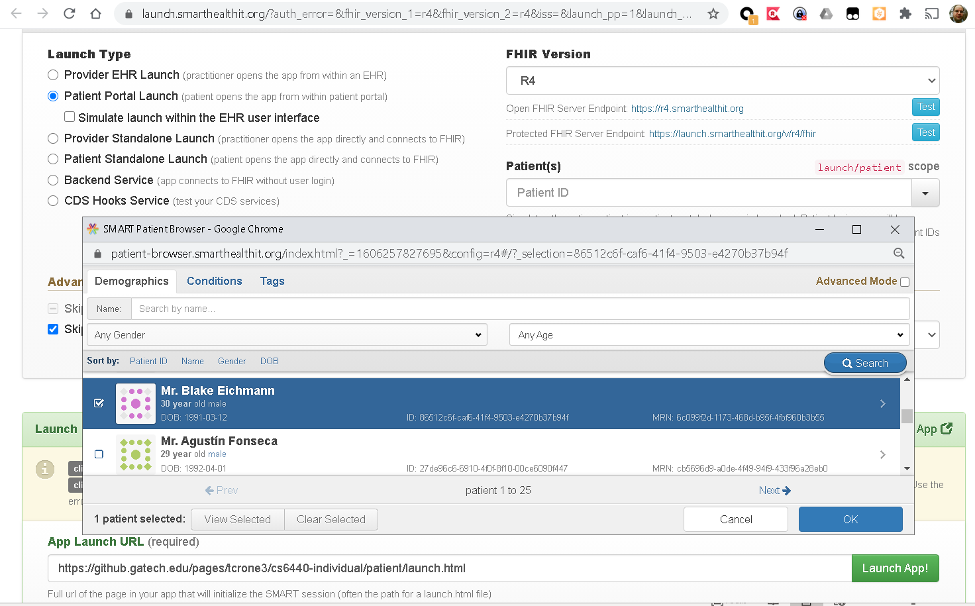

1. *Selecting a patient in the SmartHealthIT interface*

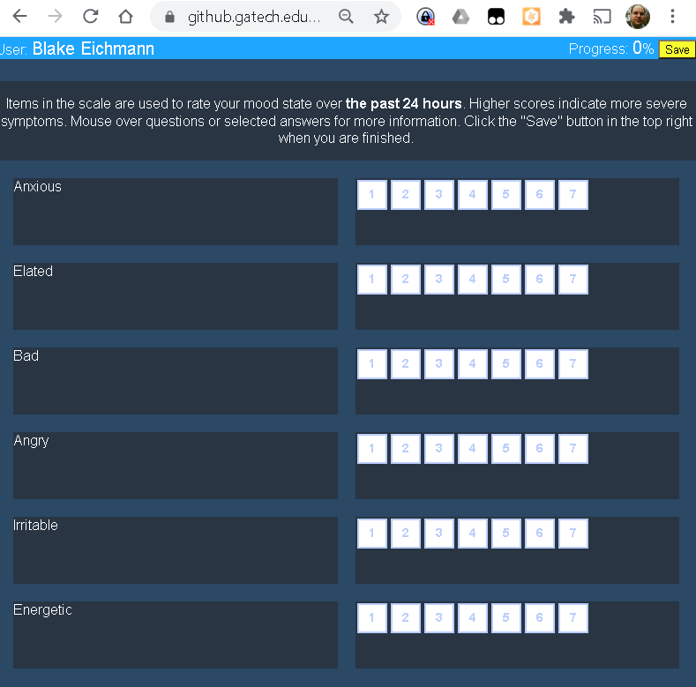When the patient interface opens, the user’s name is presented in the top left of the window; this lets the patient confirm that they are entering data in the correct account, and that it is a secure interface. Along the top row there is a progress indicator that displays how many questions have been answered, and a yellow “Save” button that allows the patient to save their progress throughout the survey.

1. *A new patient survey*

General instructions for the survey appear at the top of the screen; the patient can hover over each entry to view further information about the term. For each subjective mood state, the patient selects a value between 1 and 7 by clicking the respective box; once a value is selected the completion indicator changes concordantly, and the descriptive text in the box reflects the qualitative descrip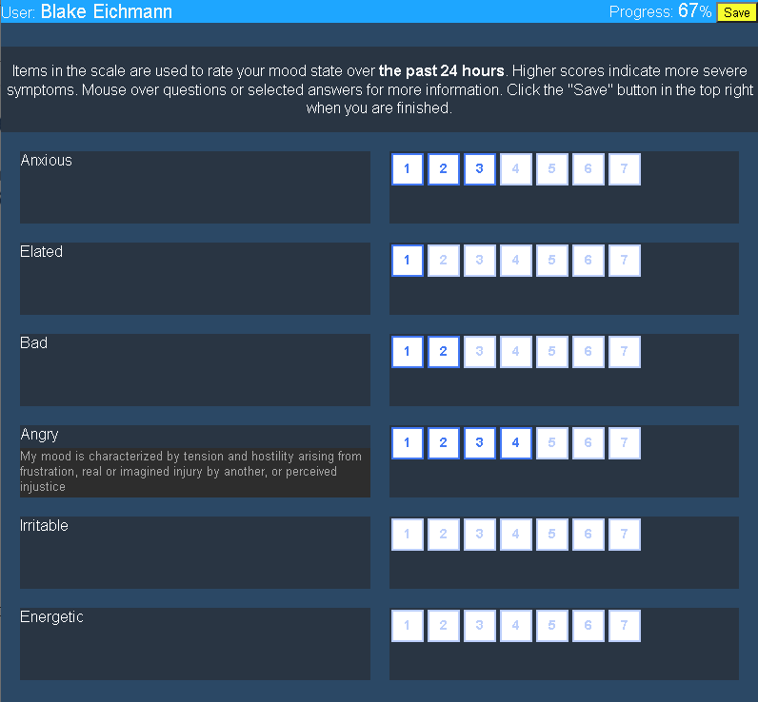tion of the selection.

1. The patient selects the subjective values for each question; in this case, the patient hovers over “Angry” for further information

Once the patient has filled out all questions in the survey, the Save button turns green to remind the user to make one final save. Once the button is clicked and the survey is saved, the button to turn black to indicate completion. The patient is then free to leave the web page or change an answer and re-save, secure in knowing that the relevant providers have access to the saved data.

1. 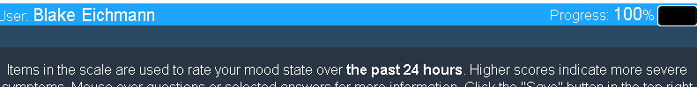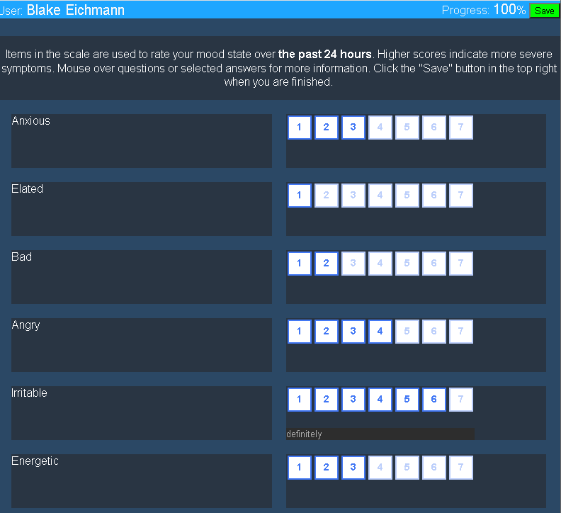The patient survey is completed; here, the patient hovers over the answer for “Irritable” to confirm the entry
2. After a save is completed the button is black, indicating the survey data has been saved to the FHIR server and the user is free to leave the site

## Provider Interface

<https://launch.smarthealthit.org/?auth_error=&fhir_version_1=r4&fhir_version_2=r4&iss=&launch_ehr=1&launch_url=https%3A%2F%2Fgithub.gatech.edu%2Fpages%2Ftcrone3%2Fcs6440-individual%2Fprovider%2Flaunch.html&patient=&prov_skip_auth=1&provider=&pt_skip_auth=1&public_key=&sb=&sde=&sim_ehr=0&token_lifetime=15&user_pt=>

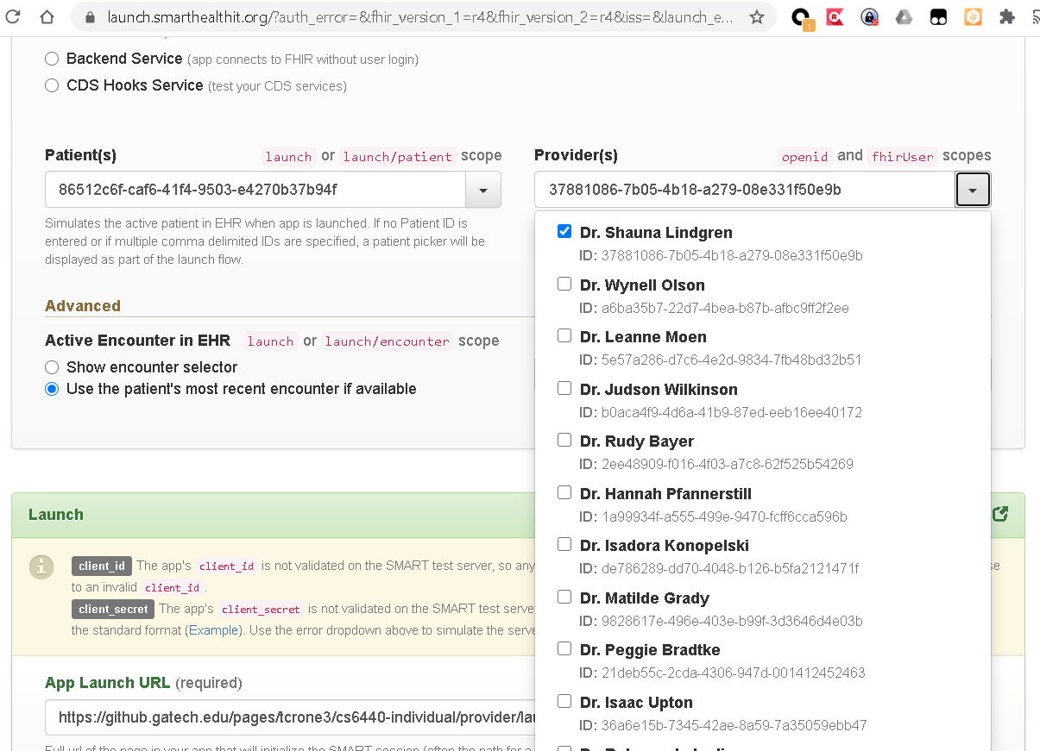As the patient interface, the provider interface can be accessed by clicking the link above. Select the same patient as before; in our case, I again selected Mr. Blake Eichmann. Select a provider; for demonstration purposes I simply selected the first, Dr. Shauna Lindgren. As before, click “Launch App!” to proceed to the provider interface.

1. The SmartHealthIT provider menu screen

### Provider Survey Interface

The provider interface includes a fixed bar at the top of the screen containing patient information, two charting buttons, a progress indicator and aggregate score, and a yellow Save button. Because the aggregate of the BDRS carries clinical meaning, the provider can gain incremental information during the process of completing the survey during a clinical visit.

The BDRS survey contains specific information about each question. By hovering over a prompt the user can view further details about that entry; once a value is selected, the description for that value is available by hovering as well. This allows a provider to quickly scan through a completed survey before saving it to the FHIR server and the patient’s record.

1. 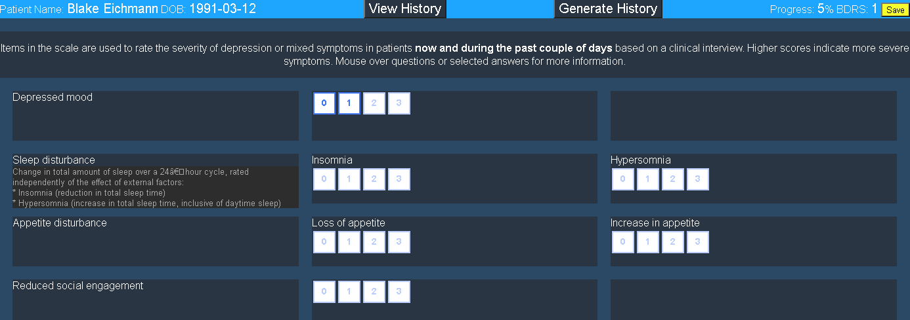A partially complete survey; here, the provider hovers over “Sleep Disturbance” for further information

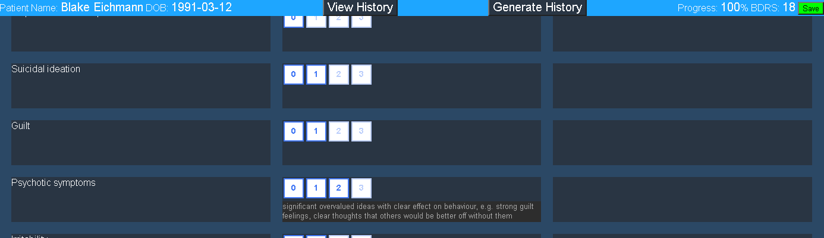Once the user has selected a response for each question, the Save button will turn green; clicking the button will save the survey data to the FHIR survey, and the button will turn black as confirmation that the provider can navigate away from the tool.

1. A completed survey; here, the provider hovers over their answer for “Psychotic Symptoms” to confirm the value
2. A completed survey; the user has successfully submitted the survey and can safely click away

### Provider Charting Interface

Because this is a test patient, the first order of business is to generate some data, otherwise the chart is not particularly interesting. Click the “Generate History” button to start the data generation process; note this takes some time to complete, and it should only be issued once. The button is removed from the bar once the generation is complete, both as a visual indicator and to prevent accidentally spawning multiple data generation cycles. The history is randomly generated using boundary rules such that there is a weak correspondence between Mood 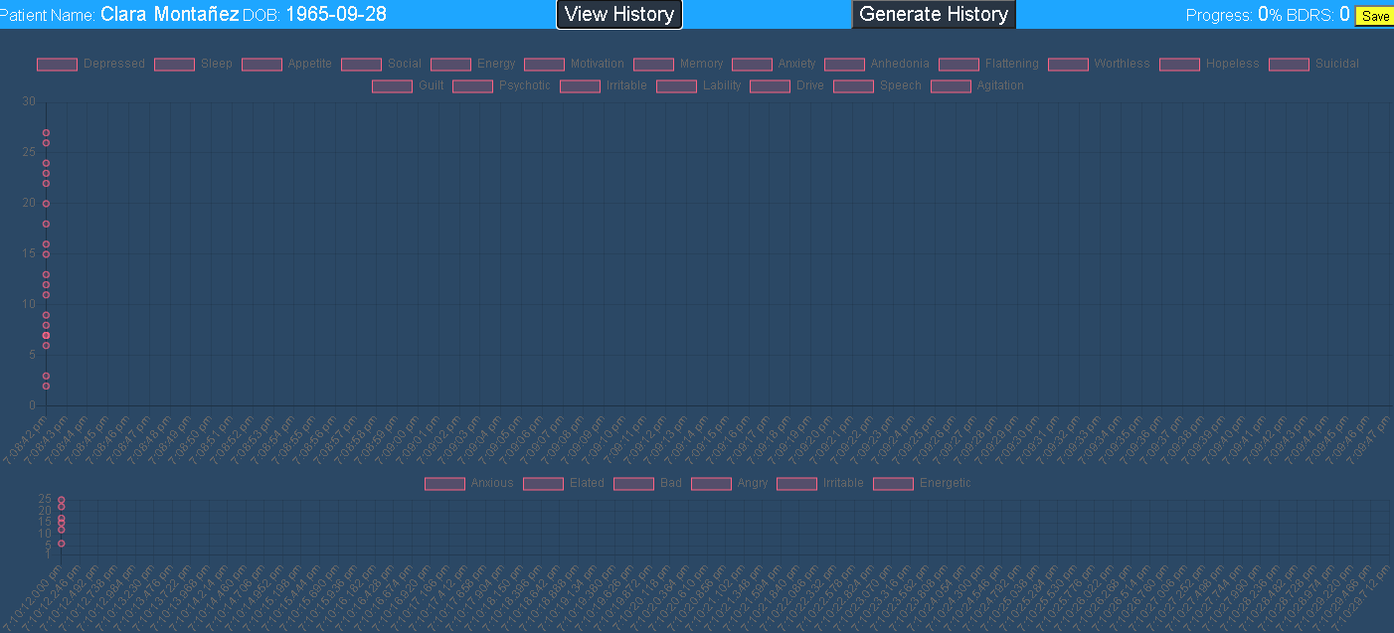Zoom and BDRS data.

1. A patient with no generated data, and a rather uninspiring chart

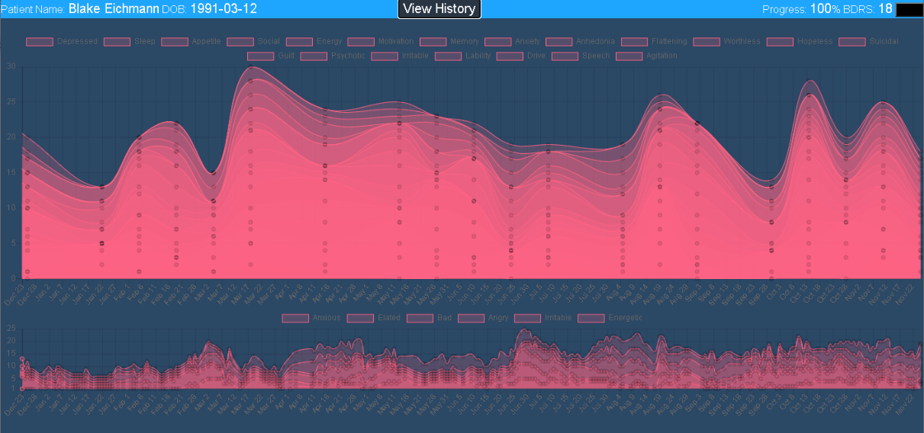With history data generated, click the “View History” button to enter the visualization. Clicking this button again allows the provider to switch between the survey and the chart views.

1. A patient with generated data; because this patient was randomly unreliable, dates from 12/22 until 11/24 are visible

By default aggregate values are shown, but the provider can deselect individual data elements to help visualize individual patterns in the data. The chart displays about 200 data points in history; depending on the reliability of the daily Mood Zoom reports this means at least 6 months of data should be visible. Because the information is all stored on the FHIR server, the provider can safely leave the visualization window and return at any time; in a real system, of course, the provider would be periodically entering observational data and reviewing the chart of their patient’s most recent submissions.

|  |  |  |  |  |  |
| --- | --- | --- | --- | --- | --- |
| Task | Week 11 | Week 12 | Week 13 | Week 14 | Week 15 |
| Develop schedule | X |  |  |  |  |
| Populate provider portal front end tasks | X |  |  |  |  |
| Submit project implementation plan | X |  |  |  |  |
| Populate patient portal front end tasks | X |  |  |  |  |
| Populate FHIR tasks | X |  |  |  |  |
| Populate provider portal charting tasks | X |  |  |  |  |
| Provider portal: design BDRS Questionnaire resource |  | X |  |  |  |
| Patient portal: design mood Questionnaire resource |  | X |  |  |  |
| Provider portal: design BDRS questionnaire front end |  | X |  |  |  |
| Patient portal: design mood questionnaire front end |  | X |  |  |  |
| Provider portal: write QuestionnaireResponse to FHIR server |  |  | X |  |  |
| Patient portal: write QuestionnaireResponse to FHIR server |  |  | X |  |  |
| Generate QuestionnaireResponse 'history': provider BDRS data |  |  | delayed | X |  |
| Generate QuestionnaireResponse 'history': patient mood data |  |  | X |  |  |
| Provider portal: add button to populate generated data |  |  | X | early |  |
| Provider portal: read historical QuestionnaireResponse data |  |  |  | X |  |
| Provider portal: chart mood and BDRS data independently |  |  |  | X |  |
| Provider portal: align displays of BDRS and mood data by date/time |  |  |  |  | X |
| Complete final documentation |  |  |  |  | X |
| Complete final presentation and other deliverables |  |  |  |  | X |

# Final Gantt Chart

<https://github.gatech.edu/tcrone3/cs6440-individual/projects/1>

1. Final schedule